Application for LAX Certified Service Provider License Agreement

The Board of Airport Commissioners approved the Certified Service Provider License Agreement (CSPLA) for Los Angeles International Airport (LAX) to grant the non-exclusive right to access the airport to companies providing services to LAX airlines and/or tenants. Companies interested in providing a Certified Service Provider Program (CSPP) regulated service(s) at LAX must meet all minimum program requirements to apply for and obtain a CSPLA.

For more information regarding the CSPP Requirements, and the CSPLA application and required attachments, please visit the CSPP website at: www.lawa.org/cspp

Please send your completed CSPLA application and required attachments to: airfieldpermits@lawa.org

We appreciate your interest and look forward to working with you throughout the application process. If you have any questions, please feel free to contact the Airfield Permits Unit at (424) 646-5880 or airfieldpermits@lawa.org.

CSPLA APPLICATION CHECKLIST

Legal/Corporate Company Name:
Business Name (dba):

Letter(s) of Intent
LAX Customer Contact Form(s)
Copy of fully executed Service Contracts
Operational Plan*
Foreign Object Debris (FOD) Prevention Plan
Corporate Documents (Articles of Incorporation)
Business Tax Registration Certificate or Exemption Letter
Active Status with the California Secretary of State
Contractor Responsibility Program (CRP) Questionnaire & Pledge of Compliance
LAX Scope of Services
LAX Annual Emergency Preparedness Training (EPT) Letter of Intent
Online LAX Alternative Fuel Vehicle Reporting Confirmation
Online LAX Ground Support Equipment (GSE) Policy Reporting Confirmation
Fictitious Business Name Statement (if applicable)
Equipment & Vehicle Inventory List (if applicable)
Non-LAWA Agency Violations Form
Company Equipment/Vehicle Authorization Letter (if applicable)
LAX Space Authorization Agreement (if applicable)
LAWA Lease/UTC/Tariff Letter/Consent to Sublease Agreement with LAWA (if applicable)
Corrective Action Plan (if applicable)

*A statement describing the nature of its business, including its capacity, experience, and qualifications to provide the requested service(s) safely and effectively at LAX.

Companies that provide CSPP regulated service(s) at LAX without a CSPLA is a violation of program requirements and may adversely impact their ability to obtain a CSPLA with LAWA.

Companies being escorted to provide any contracted CSPP regulated service(s) at LAX is a violation of LAWA's escorting policy.

NOTE: All CSPLA forms and templates are located on the CSPP website at www.lawa.org/cspp.

COMPANY PROFILE

BUSINESS INFORMATION
Legal/Corporate Company Name:

Business Name (dba):

Will your company be operating at LAX under your dba?:
Yes No N/A Describe other:

City of L.A. Business Tax Registration Certificate (BTRC) No. #:

Business Structure:

Sole Proprietorship Partnership Corporation

Limited Liability Company (LLC) Limited Partnership Other

CORPORATE CONTACT INFORMATION

Corporate Contact:
Title:
Mailing Address:
City:
State: Zip:
Work Phone: Cell Phone:
Email:
Website Address:

CSPP COMPLIANCE OFFICER INFORMATION

Name:
Title:
Mailing Address:
City:
State: Zip:
Work Phone: Cell Phone:
Email:

LAX SAFETY & TRAINING MANAGER CONTACT INFORMATION

Safety Manager Name:
Title:
Work Phone: Cell Phone:
Email:
Training Manager Name:
Title:
Work Phone: Cell Phone
Email:

BILLING CONTACT INFORMATION

Name:
Title:
Mailing Address:
City:
State: Zip:
Work Phone: Cell Phone:
Email:

ADDITIONAL COMPANY INFORMATION

Check the box that best describes your company’s Ownership and Corporate Name Changes:
- Is your firm a subsidiary, parent, holding company, or affiliate of another firm?
Yes No
If “Yes”, Please Describe:

- Have any of the firm’s owners, or officers operated a similar business in the past 5 years?
Yes No
If “Yes”, Please Describe:

- Has the firm changed names or more than 49% ownership in the past five years?
Yes No
If “Yes”, Please Describe:

- How many years has your firm been in business under its current name?

- Has your firm received any violations issued by non-LAWA regulating agencies at LAX during the past 12 months?
Yes No
If yes, please complete and submit the Non-LAWA Agency Violations Form.

BASIC INFORMATION

LAX CONTRACTS

How many executed airline/tenant contracts do you have to provide a CSPP-regulated service(s) at LAX?

PAST WORK EXPERIENCE

How many years have you been providing the selected CSPP-regulated service(s)?

How many companies have you provided the selected CSPP-regulated service(s) to in the past 3 years?

PERSONNEL AND TRAINING

Does your company currently meet the personnel and training requirements identified in Section 3.5 of the CSPP Requirements?
Yes No

Does your company currently have an employee safety training program(s) in place for LAX operations?
Yes No

Will you be providing recurrent safety training and briefings on LAX Rules and Regulations for employees at LAX?
Yes No

SERVICE AND LOCATION

SERVICE(S) AND LOCATION(S) TO BE PERFORMED

NOTE: Only one (1) Service Location Form may be submitted per LAX customer at LAX. If more than five (5), please attached list of LAX customers, service types, and locations to the CSPLA Letter of Intent.

Customer providing service(s) to:
If “Other”, Please Describe:

Locations: T1 T2 T3 T4 T5 T6 T7 T8 TBIT Cargo Other
Describe “Other” Locations:

List additional facilities/areas on LAWA property, including leased premises, where access is required to conduct business:

Core Services To Be Provided In This Contract**:
Aircraft Food Services Aircraft Line Maintenance Airfield Transportation
Baggage Management Cargo Handling Into-Plane Fueling
Ramp* Security Wheelchair Services
*Service Provider must demonstrate capacity to perform ALL services identified in the category

Limited Services To Be Provided In This Contract**:
Aircraft Cabin Cleaning Cargo Screening Terminal

Other service(s) to be provided in this contract (if any)

**For more details, please see List of CSPP-Regulated Services at LAX.

LAX AIRFIELD ACCESS

Will motor vehicles, equipment, and/or pedestrian traffic be required to access the restricted airfield and/or non-public areas of the airport?
Equipment * Yes No
Vehicles * Yes No
Pedestrian Only Yes No
*Service Provider must be in compliance with all LAX Alternative Fuel Vehicle and GSE Emissions Reduction Policy reporting requirements.

Will your company provide authorization for other companies to use your equipment and/or vehicles for LAX operations? Yes No
If yes, a Company Vehicle/Equipment Authorization Letter must be submitted to LAWA.

FOR ADDITIONAL SERVICE AND LOCATION FORMS, PLEASE CLICK HERE.

ESTIMATED ANNUAL GROSS REVENUE FOR ALL CONTRACTS AT LAX

CSPP MONTHLY GROSS REVENUE FEE SCHEDULE

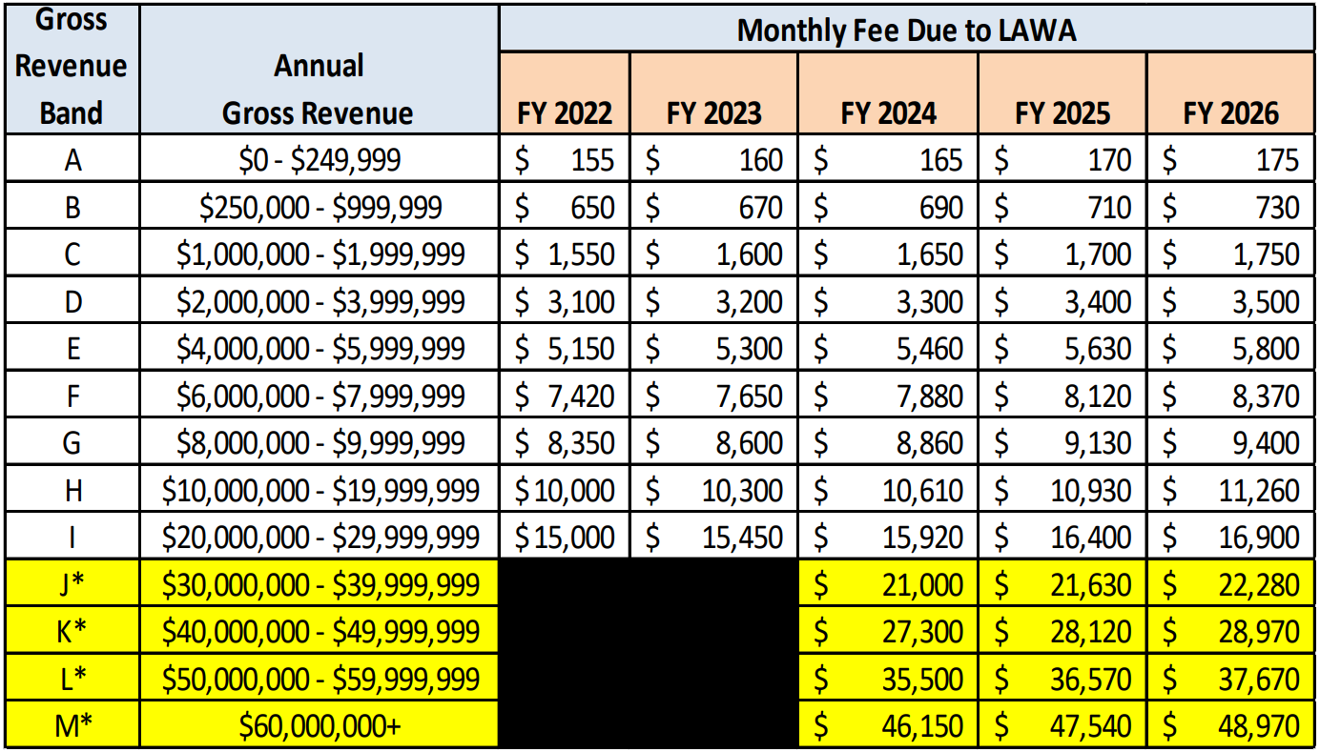

Enter your estimated annual gross revenue for service(s) provided at LAX:

NOTE: The Faithful Performance Guarantee (FPG) required amount is three (3) times the amount of the CSPP monthly fee, and must be maintained throughout the term of the CSPLA. An irrevocable Letter of Credit (LOC) must be submitted if your FPG amount is $10,000 or greater. For click on LAWA FPG LOC Requirements for more details.

PAST WORK EXPERIENCE*

*Service providers are required to submit past work experience forms if they are providing a Core CSPP-regulated service(s) at LAX. Please see List of CSPP-Regulated Services for more details.

CUSTOMER CONTACT

Name of Company:
Address: (optional):
City: (optional):
State: (optional):
Zip: (optional):
Name of Contact:
Title/ Position:
Phone:
Email:

TERM OF CONTRACT
Month & Year Contract Began:
Month & Year Contract Ended:

Services Provided:
Aircraft Food Services Aircraft Line Maintenance Airfield Transportation
Baggage Management Cargo Handling Into-Plane Fueling
Ramp* Security Wheelchair Services

NOTE: Service provider must demonstrate a record evidencing successful general operating experience for at least three (3) of the last five (5) years at a large hub airport in the United States or airports outside of the United States that are of similar size to large hub airports. Please see CSPP Requirements for more details.

FOR ADDITIONAL WORK EXPERIENCE FORMS, PLEASE CLICK HERE.

FACILITIES AND SPACE INFORMATION

LAWA Lease Space Agreements
Do you have or currently in process of executing a direct Lease Agreement with Los Angeles World Airports (LAWA)? Yes No
If yes, please enter the LAWA Lease Agreement Number and expiration date. Or select “In Process”
In Process
LAWA Agreement Number Start Date End Date Square Footage

Do you have or currently in process of executing a Consent to Sublease Agreement with LAWA?
Yes No
If yes, please provide the effective dates. Or select “In Process” below:
In Process
Airline/ Tenant Agreement Number Start Date End Date Square Footage

Do you have or currently in process of executing a Tariff Letter or Use, Terms and Conditions (UTC) Agreement with LAWA? Yes No
If yes, please provide the effective dates. Or select “In Process” below:
In Process
Tariff Letter Agreement Number Start Date End Date* Square Footage

UTC Agreement Agreement Number Start Date End Date* Square Footage

*Leave “End Date” Blank if agreement is open ended

LAX Space Authorization Agreement
Do you have or currently in process of executing a LAX Space Authorization Agreement with a master tenant (leaseholder) at LAX? Yes No
In Process
LAX Master Tenant Agreement Term

Location Address

NOTE: Only companies needing to store or repair equipment/vehicles on airport property are required to secure adequate space PRIOR to obtaining a CSPLA for operations at LAX. Excludes LAX Food Service providers.

Off-Airport Facilities for LAX-related Services
Are you using facilities for LAX-related services off-airport (LAWA) property?
Yes No

Street Address:
City, State & Zip Code:
Square Footage:

Street Address:
City, State & Zip Code:
Square Footage:

Street Address:
City, State & Zip Code:
Square Footage:

Street Address:
City, State & Zip Code:
Square Footage:

AIRFIELD VEHICLE PARKING

Airfield Vehicle Parking
Will you be parking or storing vehicles on the airfield for operations at LAX?
Yes No

Location #1:
Anticipated Security Post Access: P1 P2 P3 P4 P5 P21 N/A
Other Access:
Approximate Number Of Vehicles:

Location #2:
Anticipated Security Post Access: P1 P2 P3 P4 P5 P21 N/A
Other Access:
Approximate Number Of Vehicles:

Location #3:
Anticipated Security Post Access: P1 P2 P3 P4 P5 P21 N/A
Other Access:
Approximate Number Of Vehicles:

Location #4:
Anticipated Security Post Access: P1 P2 P3 P4 P5 P21 N/A
Other Access:
Approximate Number Of Vehicles:

Location #5:
Anticipated Security Post Access: P1 P2 P3 P4 P5 P21 N/A
Other Access:
Approximate Number Of Vehicles:

CSPLA VERIFICATION & EXECUTIVE OFFICERS

LAX AUTHORIZED SIGNER CONTACT INFORMATION
Print Full Name:
Title:
Email:
EXECUTIVE OFFICERS CONTACT INFORMATION
Must Provide two different Executive Officer names with authority to sign the CSPLA.
All fields must be entered.

Full Name of Signer #1:
Title:
Email Address:

Full Name of Signer #2:
Title:
Email Address:

CSPLA VERIFICATION E-SIGNATURE
The person identified below hereby verifies that they prepared the above and forgoing application and that it is true and correct to the best of their knowledge and belief.

Print Full Name:
Title:
Date Submitted:

